1. Auction Mark and Sale Proceed

Add separate fill to enter sale proceed for individulay tickets. Upset value and sale proceed can be enter sperately. Till sale proceds vlaue enterd tickt should be apper in this screen.

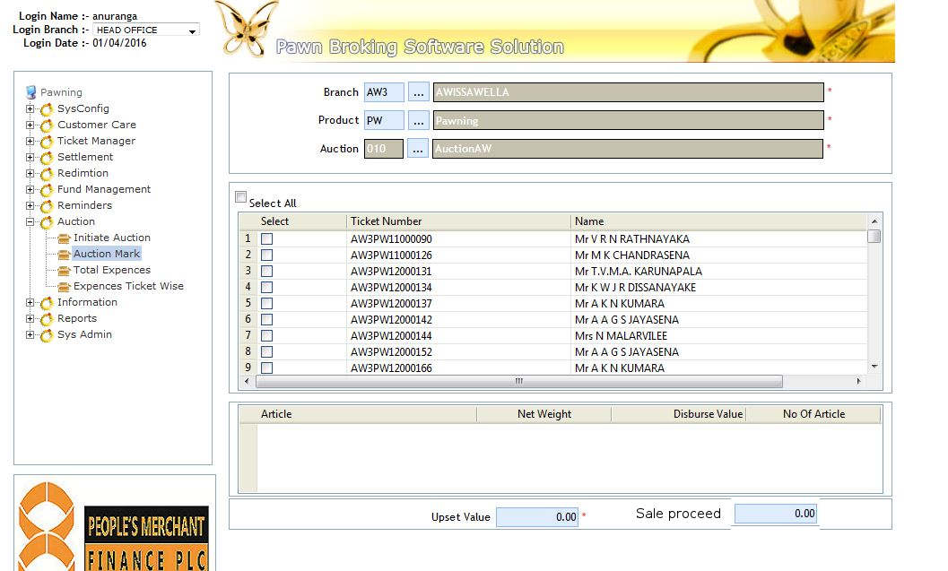

1. Auction Close

There should be option to close auction after entered all sales proceeds and allocate expenses.

After close the auction system not allow adding any tickets to the auction and all tickets should be closed.

1. Auction report.

Auction report should be modified to select auction code (optional) alone with the date range. Further Auction code should be printed on the auction report.